Experiment No: 4 (Software) Date: 10-09-2022
DESIGN OF ENCODER AND DECODER USING LOGIC GATES
Register Number: 21BEC1851
Name: Rahul Karthik S
Aim:
To design and construct a decoder and encoder circuit with logic gates using Verilog.
Software Required:
ModelSim
Theory:
Decoder:
The name “Decoder” means to translate or decode coded information from one format into another, so a digital decoder transforms a set of digital input signals into an equivalent decimal code at its output.
A decoder is a combinational circuit that converts binary information from n input lines to a maximum of m=2n unique output lines.
Encoder:
An Encoder is a combinational circuit that performs the reverse operation of Decoder. It has maximum of 2^{n} input lines and ‘n’ output lines. It will produce a binary code equivalent to the input, which is active High. Therefore, the encoder encodes 2n input lines with ‘n’ bits. It is optional to represent the enable signal in encoders.

Procedure:
- Open ModelSim.
- Click Jumpstart and create new project.
- The create new file and select Verilog from the drop-down.
- Type the code, compile it.
- Follow (3) and do the test bench, compile it.
- Then, simulate the test bench file and run it.
- After that follow the same procedure for encoders.
Observation:
2 to 4 Decoder:
Truth Table:
Enable | Inputs |  | Output
E | A | B | Y₃ | Y₂ | Y₁ | Y₀
0 | X | X | 0 | 0 | 0 | 0
1 | 0 | 0 | 0 | 0 | 0 | 1
1 | 0 | 1 | 0 | 0 | 1 | 0
1 | 1 | 0 | 0 | 1 | 0 | 0
1 | 1 | 1 | 1 | 0 | 0 | 0
Logic Diagram:
4 to 2 Encoder:
Truth Table:
Inputs |  |  |  | Output
Y₃ | Y₂ | Y₁ | Y₀ | A₁ | A₀
0 | 0 | 0 | 1 | 0 | 0
0 | 0 | 1 | 0 | 0 | 1
0 | 1 | 0 | 0 | 1 | 0
1 | 0 | 0 | 0 | 1 | 1
Logic Diagram:
A1= Y3+Y2
A0=Y1+Y3
Verilog Code:
2 to 4 Decoder:
Gate Modelling:
module dg(a,b,y0,y1,y2,y3,e);
input a,b,e;
output y0,y1,y2,y3;
wire i1,i2;
not a1(i1,a);
not a2(i2,b);
and a3(y0,i1,i2,e);
and a4(y1,i1,b,e);
and a5(y2,a,i2,e);
and a6(y3,a,b,e);
endmodule
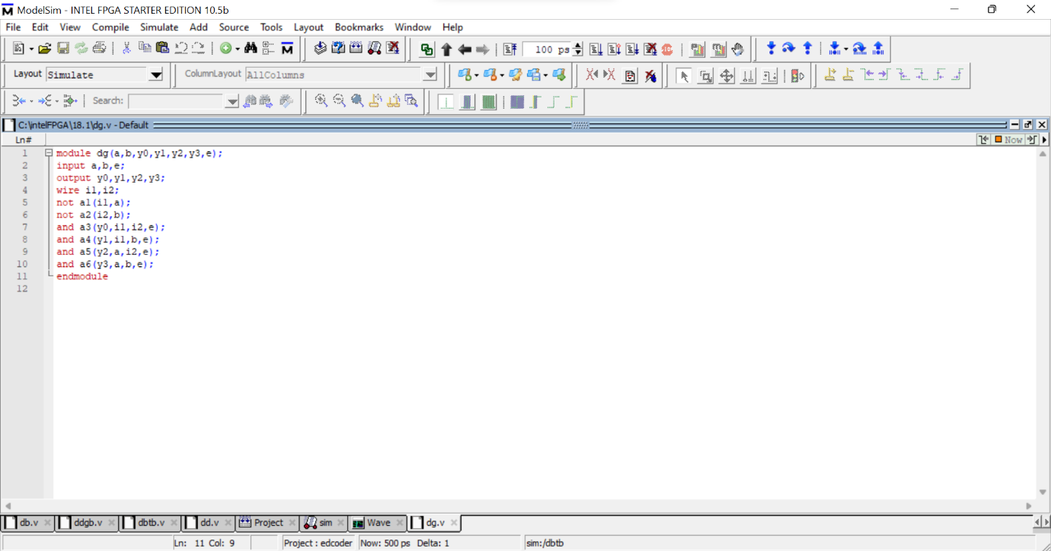
Test Bench for Gate Modelling:
module dgtb;
reg a,b,e;
wire y0,y1,y2,y3;
dg a1(.y0(y0),.y1(y1),.y2(y2),.y3(y3),.a(a),.b(b),.e(e));
initial begin
$monitor(y0,y1,y2,y3,a,b,e);
e=1'b0;
a=1'b0;
b=1'b0;
#100
e=1'b1;
a=1'b0;
b=1'b0;
#100;
e=1'b1;
a=1'b0;
b=1'b1;
#100;
e=1'b1;
a=1'b1;
b=1'b0;
#100;
e=1'b1;
a=1'b1;
b=1'b1;
#100;
end
endmodule
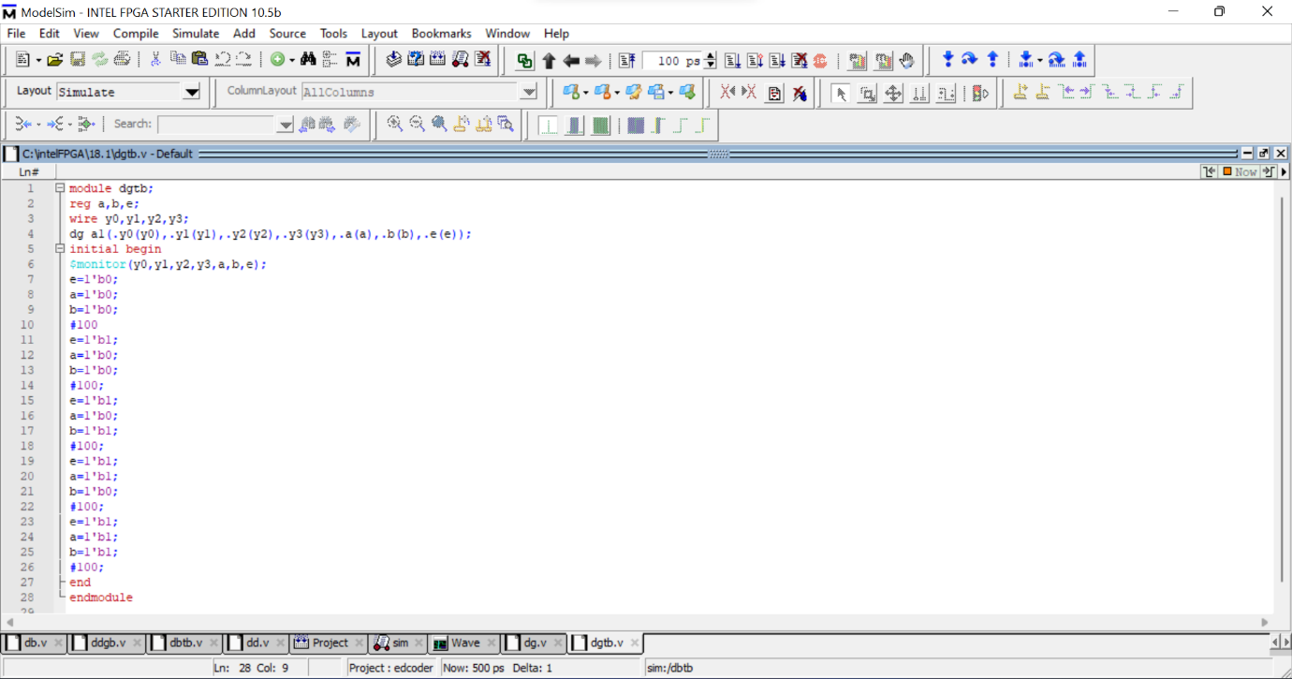
Data-Flow Modelling:
module dd(a,b,y0,y1,y2,y3,e);
input a,b,e;
output y0,y1,y2,y3;
assign y0 = (~a) & (~b) & e;
assign y1 = (~a) & b & e;
assign y2 = a & (~b) & e;
assign y3 = a & b & e;
endmodule
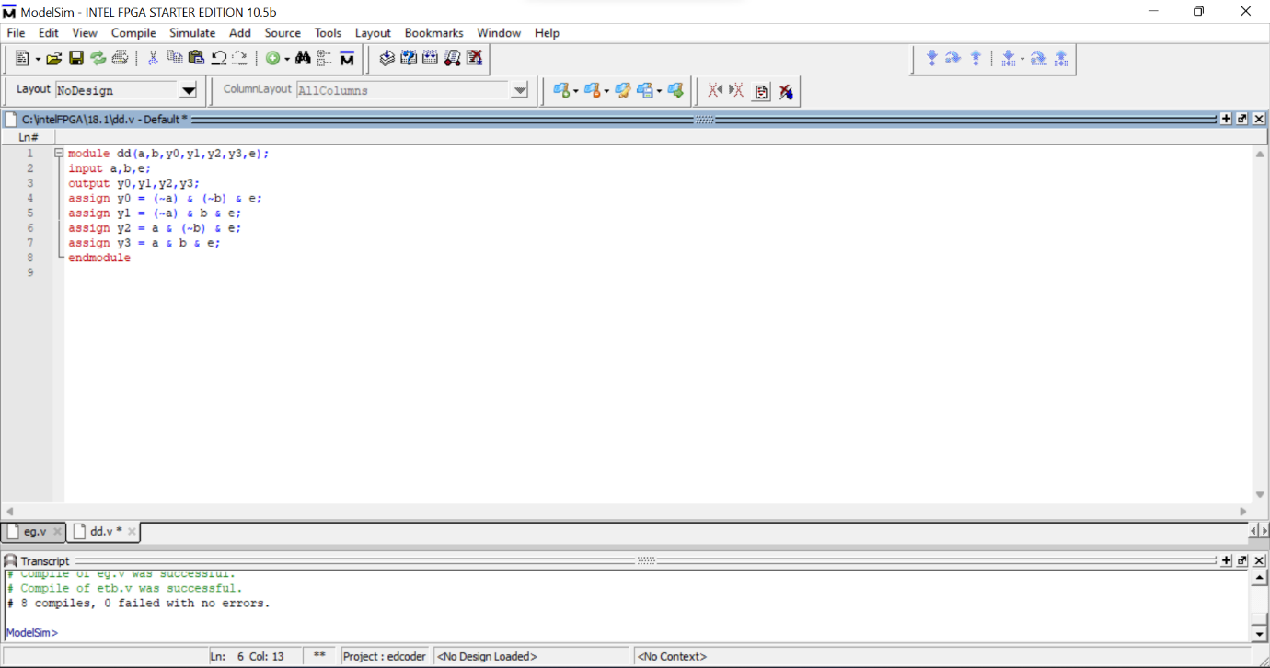
Test Bench for Data-Flow Modelling:
module ddtb;
reg a,b,e;
wire y0,y1,y2,y3;
dd a1(.y0(y0),.y1(y1),.y2(y2),.y3(y3),.a(a),.b(b),.e(e));
initial begin
$monitor(y0,y1,y2,y3,a,b,e);
e=1'b0;
a=1'b0;
b=1'b0;
#100
e=1'b1;
a=1'b0;
b=1'b0;
#100;
e=1'b1;
a=1'b0;
b=1'b1;
#100;
e=1'b1;
a=1'b1;
b=1'b0;
#100;
e=1'b1;
a=1'b1;
b=1'b1;
#100;
end
endmodule
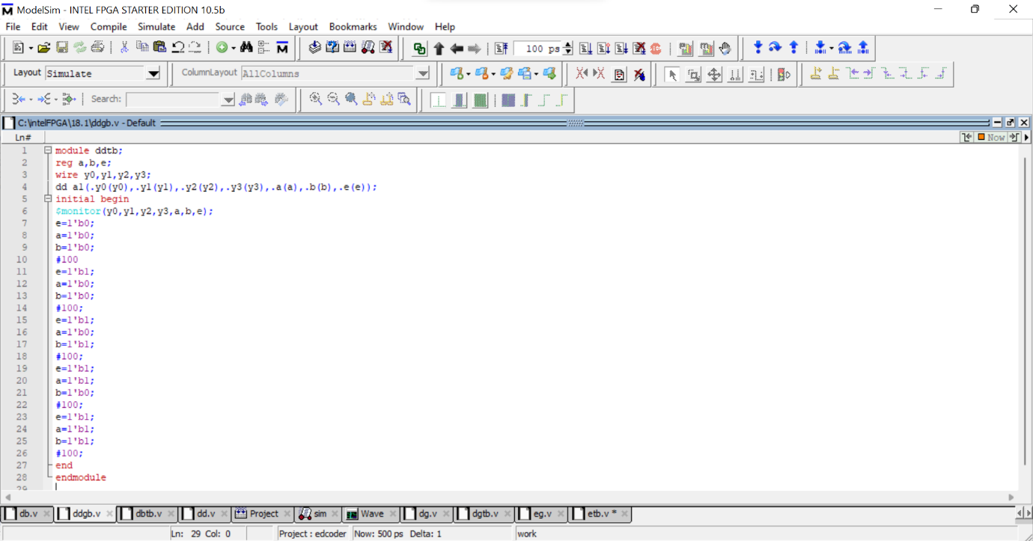
Behavioral Modelling:
module dg(y,a,b,e);
input a,b,e;
output reg [0:3]y;
always @ (a or b or e)
begin
if (e == 1)
if (a==1'b0 & b==1'b0)
y= 4'b1000;
else if(a==1'b0 & b==1'b1)
y=4'b0100;
else if(a==1'b1 & b==1'b0)
y=4'b0010;
else if(a==1'b1 & b==1'b1)
y=4'b0001;
else
y=4'b0000;
end
endmodule
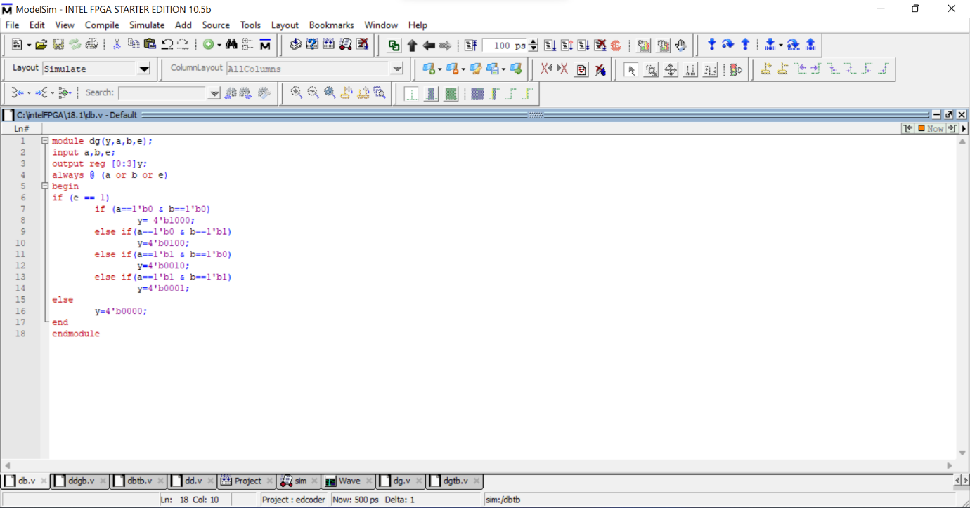
Test Bench for Behavioral Modelling:
module dbtb;
reg a,b,e;
wire [0:3]y;
dg a1(.y(y),.a(a),.b(b),.e(e));
initial begin
$monitor(y,a,b,e);
e=1'b0;
a=1'b0;
b=1'b0;
#100
e=1'b1;
a=1'b0;
b=1'b0;
#100;
e=1'b1;
a=1'b0;
b=1'b1;
#100;
e=1'b1;
a=1'b1;
b=1'b0;
#100;
e=1'b1;
a=1'b1;
b=1'b1;
#100;
end
endmodule
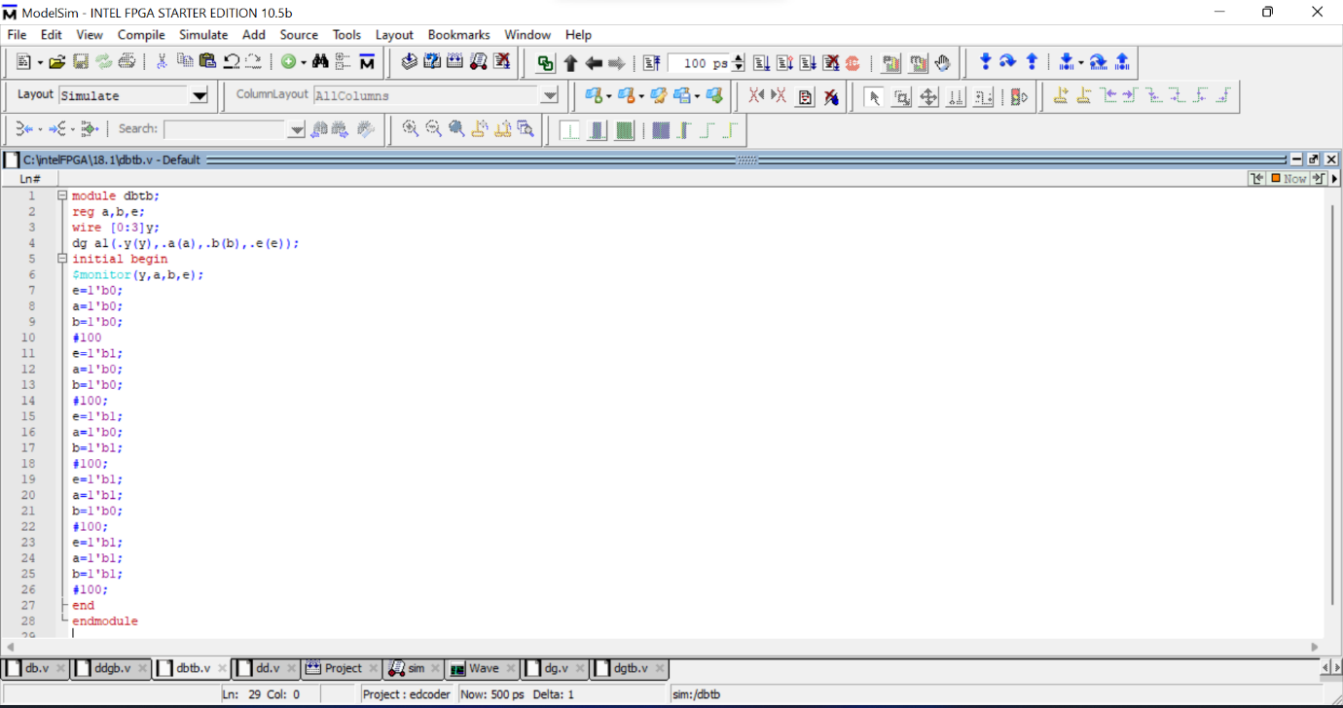
4 to 2 Encoder:
Gate Modelling:
module eg(y3,y2,y1,y0,a1,a0);
input y3,y2,y1,y0;
output a1,a0;
or o1(a1,y3,y2);
or o2(a0,y3,y1);
endmodule
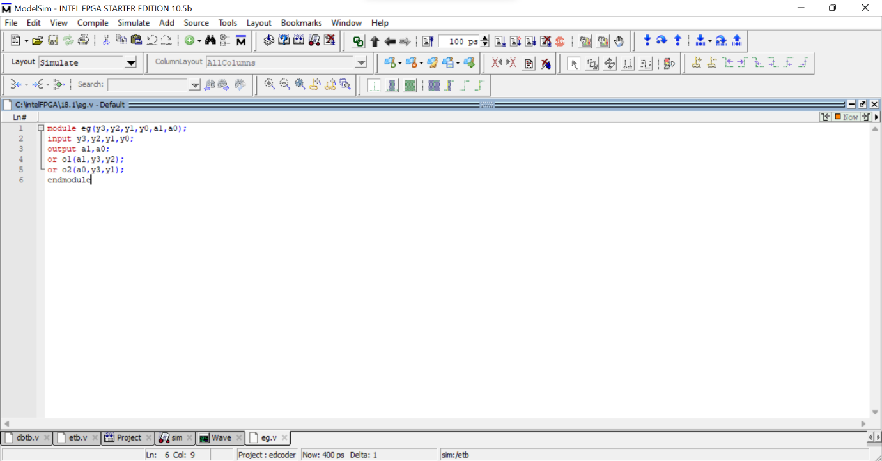
Test Bench for Gate Modelling:
module etb;
reg y0,y1,y2,y3;
wire a0,a1;
eg o1(.y0(y0),.y1(y1),.y2(y2),.y3(y3),.a0(a0),.a1(a1));
initial begin
$monitor(a1,a0,y0,y1,y2,y3);
y0=1'b0;
y1=1'b0;
y2=1'b0;
y3=1'b1;
#100
y0=1'b0;
y1=1'b0;
y2=1'b1;
y3=1'b0;
#100;
y0=1'b0;
y1=1'b1;
y2=1'b0;
y3=1'b0;
#100;
y0=1'b1;
y1=1'b0;
y2=1'b0;
y3=1'b0;
#100;
end
endmodule
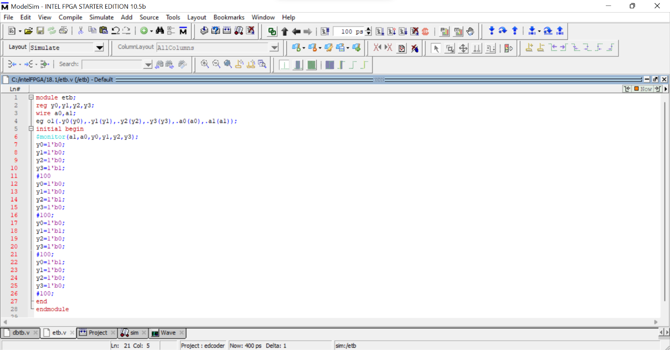
Data-Flow Modelling:
module eg(y3,y2,y1,y0,a1,a0);
input y3,y2,y1,y0;
output a1,a0;
assign a1 = y3|y2;
assign a0 = y3|y1;
endmodule
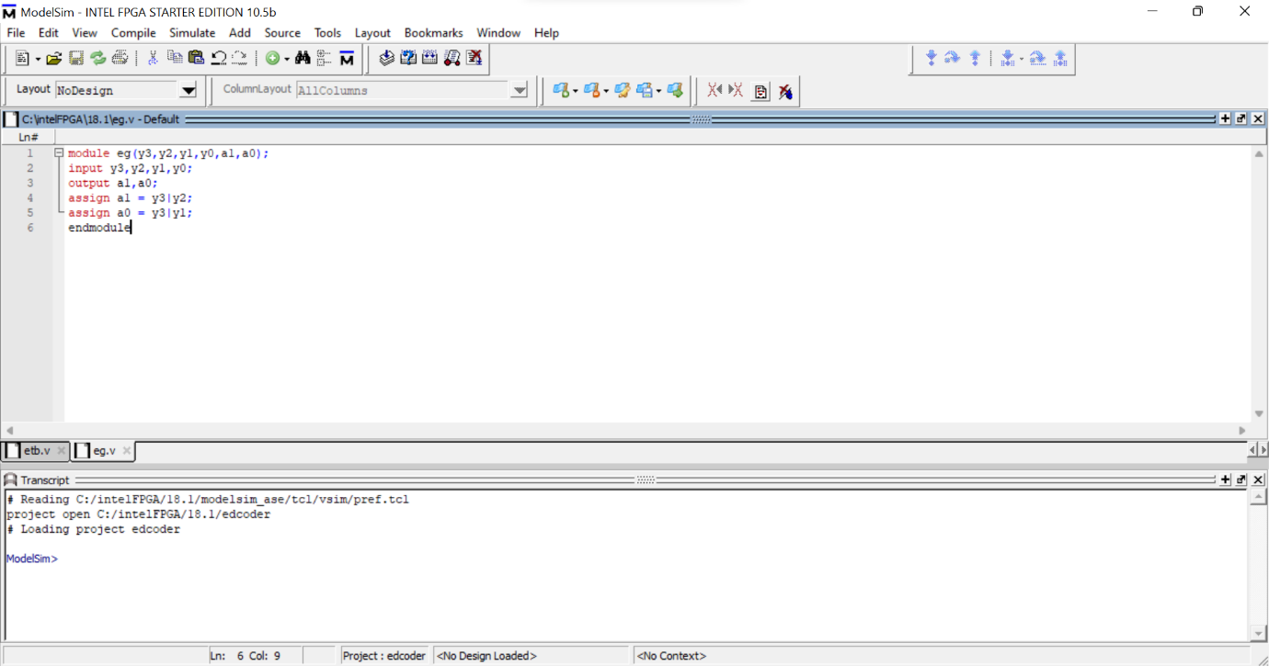
Test Bench for Data-Flow Modelling:
module etb;
reg y0,y1,y2,y3;
wire a0,a1;
eg o1(.y0(y0),.y1(y1),.y2(y2),.y3(y3),.a0(a0),.a1(a1));
initial begin
$monitor(a1,a0,y0,y1,y2,y3);
y0=1'b0;
y1=1'b0;
y2=1'b0;
y3=1'b1;
#100
y0=1'b0;
y1=1'b0;
y2=1'b1;
y3=1'b0;
#100;
y0=1'b0;
y1=1'b1;
y2=1'b0;
y3=1'b0;
#100;
y0=1'b1;
y1=1'b0;
y2=1'b0;
y3=1'b0;
#100;
end
endmodule
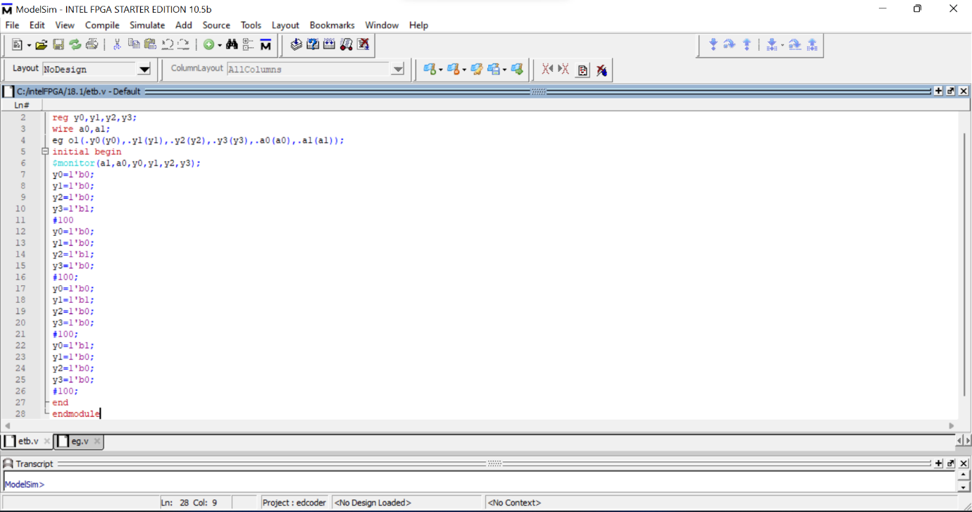
Behavioral Modelling:
module eg(y3,y2,y1,y0,a1,a0);
input y3,y2,y1,y0;
output reg a1,a0;
always @ (y3,y2,y1,y0)
case({y3,y2,y1,y0})
4'b0001 : begin a1 = 0; a0 = 0; end
4'b0010 : begin a1 = 0; a0 = 1; end
4'b0100 : begin a1 = 1; a0 = 0; end
4'b1000 : begin a1 = 1; a0 = 1; end
endcase
endmodule

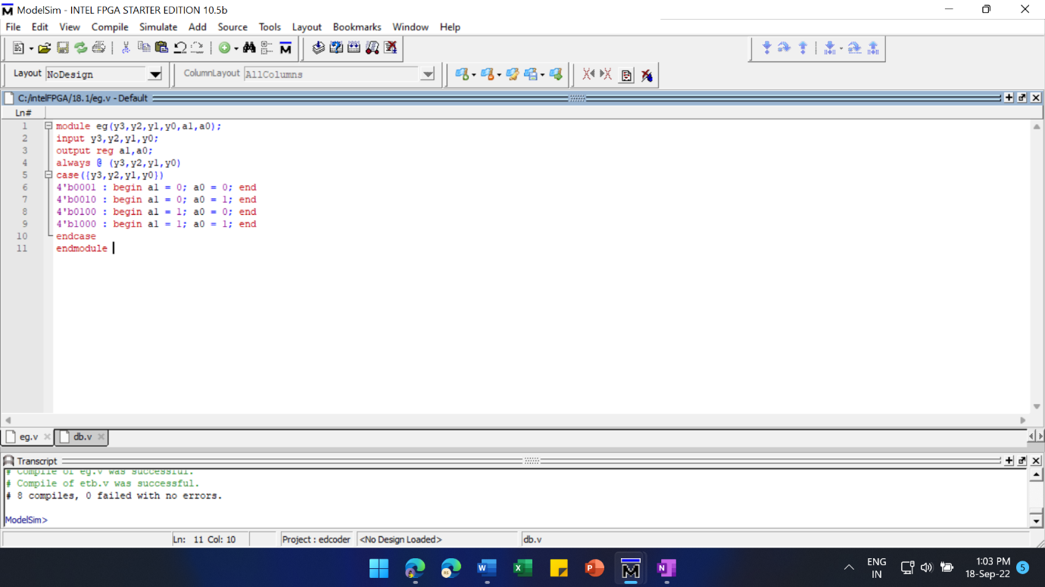Test Bench for Behavioral Modelling:
module etb;
reg y0,y1,y2,y3;
wire a0,a1;
eg o1(.y0(y0),.y1(y1),.y2(y2),.y3(y3),.a0(a0),.a1(a1));
initial begin
$monitor(a1,a0,y0,y1,y2,y3);
y0=1'b0;
y1=1'b0;
y2=1'b0;
y3=1'b1;
#100
y0=1'b0;
y1=1'b0;
y2=1'b1;
y3=1'b0;
#100;
y0=1'b0;
y1=1'b1;
y2=1'b0;
y3=1'b0;
#100;
y0=1'b1;
y1=1'b0;
y2=1'b0;
y3=1'b0;
#100;
end
endmodule

Output:
2 to 4 Decoder:
Gate Modelling:
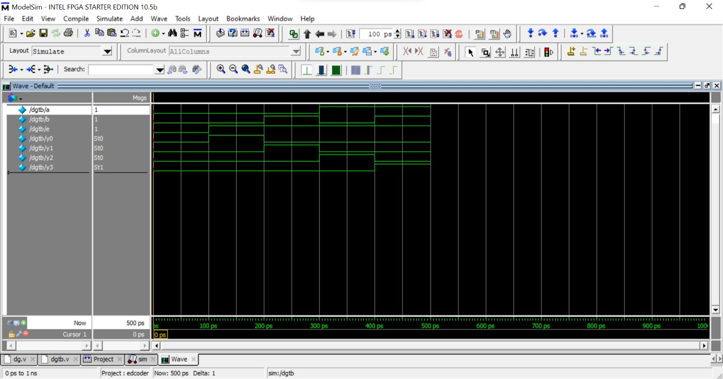
Data Flow Modelling:
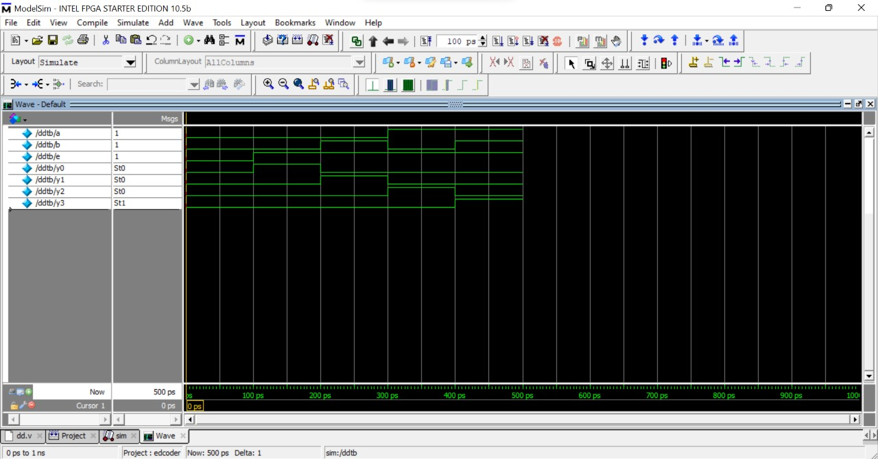
Behavioral Modelling:
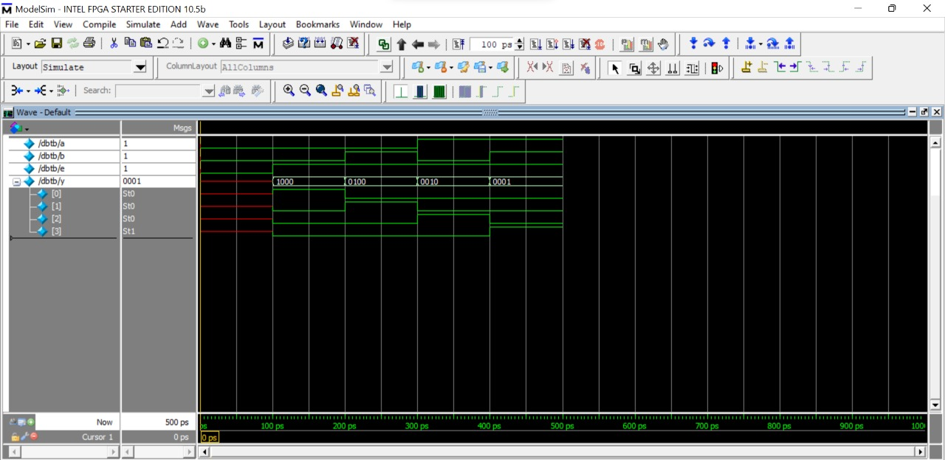
4 to 2 Encoder:
Gate Modelling:
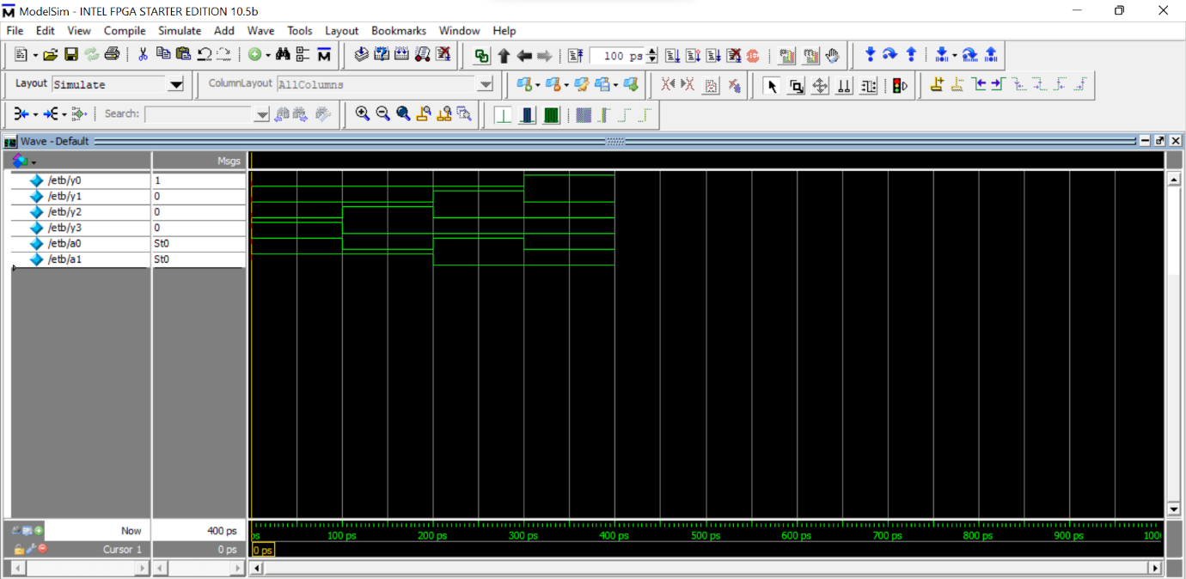
Data Flow Modelling:

Behavioral Modelling:

Result: The encoder and decoder were designed and constructed using logic gates and their truth table was verified using Verilog.

